**Class:** Final Year (Computer Science and Engineering)

**Year:** 2022-23 **Semester:** 1

**Course:** High Performance Computing Lab

**Practical No. 10**

**Exam Seat No:**

2019BTECS00037 – Onkar Gavali

**Title of practical:**

Implementation of Matrix-matrix Multiplication, Prefix sum, 2D Convolution using CUDA C

**Problem Statement 1:**

Implement Matrix-matrix Multiplication using global memory in CUDA C. Analyze and tune the program for getting maximum speed up. Do Profiling and state what part of the code takes the huge amount of time to execute.

*#include <stdio.h>*

*#define row1 20*

*#define col1 30*

*#define row2 30*

*#define col2 20*

*__global__ void matmul(int *l, int *m, int *n)*

*{*

*int x = threadIdx.x;*

*int y = threadIdx.y;*

*int k;*

*n[col2 * y + x] = 0;*

*for (k = 0; k < col1; k++)*

*{*

*n[col2 * y + x] = n[col2 * y + x] + l[col1 * y + k] * m[col2 * k + x];*

*}*

*}*

*int main()*

*{*

*int a[row1][col1];*

*int b[row2][col2];*

*int c[row1][col2];*

*int *d, *e, *f;*

*int i, j;*

*for (i = 0; i < row1; i++)*

*{*

*for (j = 0; j < col1; j++)*

*{*

*a[i][j] = 2;*

*}}*

*for (i = 0; i < row2; i++)*

*{*

*for (j = 0; j < col2; j++)*

*{*

*b[i][j] = 3;*

*}*

*}*

*cudaMalloc((void **)&d, row1 * col1 * sizeof(int));*

*cudaMalloc((void **)&e, row2 * col2 * sizeof(int));*

*cudaMalloc((void **)&f, row1 * col2 * sizeof(int));*

*cudaMemcpy(d, a, row1 * col1 * sizeof(int), cudaMemcpyHostToDevice);*

*cudaMemcpy(e, b, row2 * col2 * sizeof(int), cudaMemcpyHostToDevice);*

*dim3threadBlock(col2, row1);*

*matmul<<<1, threadBlock>>>(d, e, f);*

*cudaDeviceSynchronize();*

*cudaMemcpy(c, f, row1 * col2 * sizeof(int), cudaMemcpyDeviceToHost);*

*for (i = 0; i < row1; i++)*

*{*

*for (j = 0; j < col2; j++)*

*{*

*if (c[i][j] != 180)*

*{*

*printf("False\n");*

*return -1;*

*}*

*}*

*}*

*cudaFree(d);*

*cudaFree(e);*

*cudaFree(f);*

*printf("True\n");*

*return 0;*

*}*

**Output:**

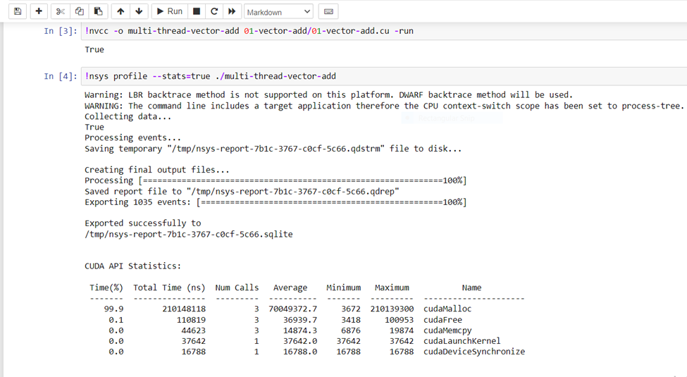

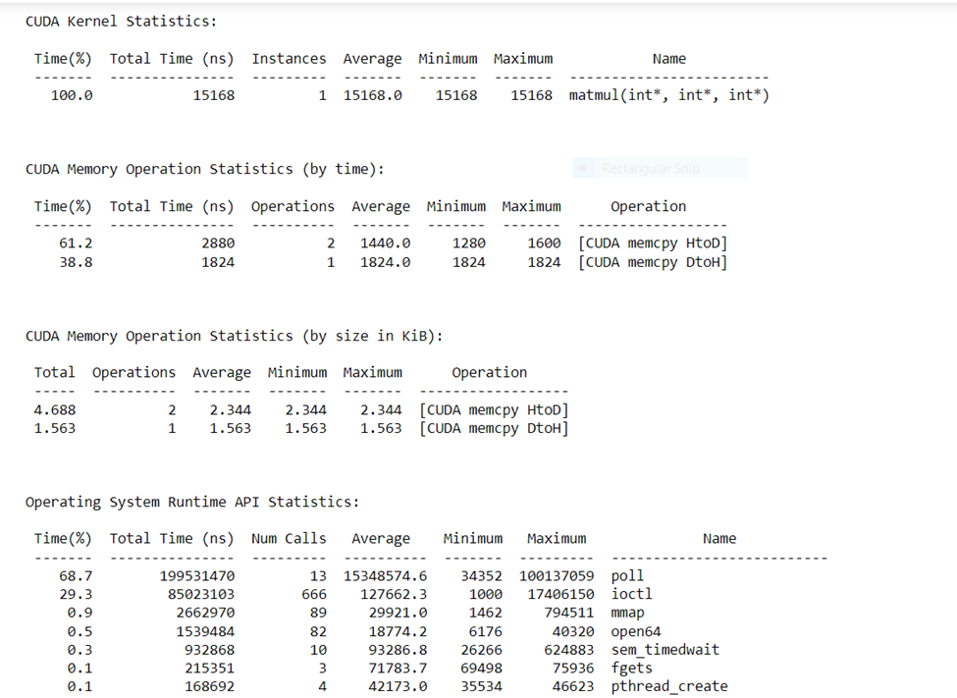

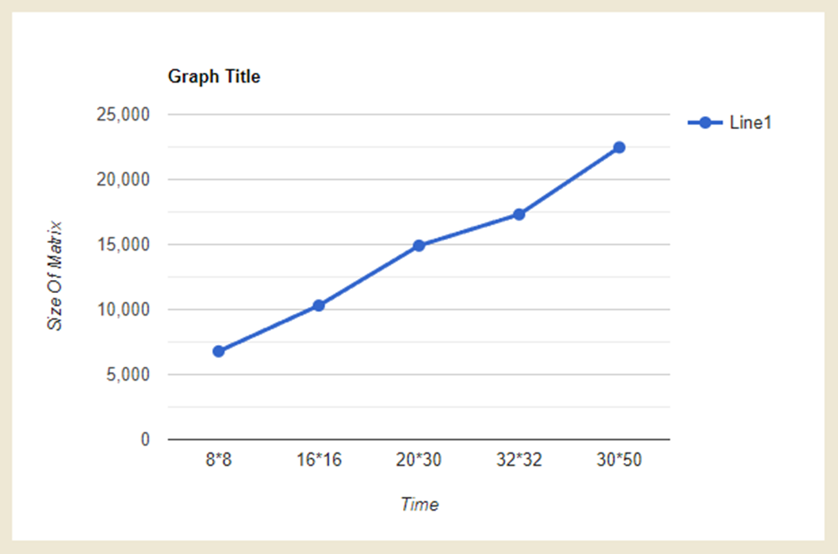

| Problem Size | Time Required |
| --- | --- |
| 8*8 | 6784 |
| 16*16 | 10304 |
| 20*30 | 14911 |
| 32*32 | 17312 |
| 30*50 | 22464 |

**Problem Statement 2:**

Implement Matrix-Matrix Multiplication using shared memory in CUDA C. Analyze and tune the program for getting maximum speed up. Do Profiling and state what part of the code takes the huge amount of time to execute.

**Code:**

#include <stdio.h>

#include <string.h>

#include <cuda.h>

#include "cuda_runtime.h"

#include "device_launch_parameters.h"

#include "math.h"

#include "time.h"

#include <iostream>

#include <fstream>

#include <iomanip>

#define BLOCK_SIZE 32

voidprint_matrices(float* matrix, char*file_Name, intx_dim, inty_dim, int dim)

{

std::ofstreamoutFile;

outFile.open (file_Name);

outFile<<std::fixed;

outFile<<std::setprecision(2);

for (int i = 0; i <x_dim; i++) {

for (int j = 0; j <y_dim; j++) {

outFile<< matrix[i * dim + j] <<" ";

}

outFile<<std::endl;

}

}

__host__voidcpu_matrix_mult(float*h_a, float*h_b, float*h_result, int m) {

for (int i = 0; i < m; ++i)

{

for (int j = 0; j < m; ++j)

{

floattmp = 0.0;

for (int h = 0; h < m; ++h)

{

tmp += h_a[i * m + h] * h_b[h * m + j];

}

h_result[i * m + j] = tmp;

}

}

}

__host__intfill(float**Lmatrix, float**Rmatrix, intLdimX, intLdimY, intRdimX, intRdimY) {

intsqr_dim_X, sqr_dim_Y, size;

sqr_dim_X = RdimX;

if (LdimX>RdimX) {

sqr_dim_X = LdimX;

}

sqr_dim_Y = RdimY;

if (LdimY>RdimY) {

sqr_dim_Y = LdimY;

}

size = sqr_dim_Y;

if (sqr_dim_X>sqr_dim_Y) {

size = sqr_dim_X;

}

int temp = size / BLOCK_SIZE + (size % BLOCK_SIZE == 0 ? 0 : 1);

size = temp * BLOCK_SIZE;

size_tpt_size = size * size * sizeof(float);

*Lmatrix = (float *) malloc(pt_size);

*Rmatrix = (float *) malloc(pt_size);

memset(*Lmatrix, 0, pt_size);

memset(*Rmatrix, 0, pt_size);

for (int i = 0; i <LdimX; i++) {

for (int j = 0; j <LdimY; j++) {

int dummy = size * i + j;

(*Lmatrix)[dummy] = sinf(dummy);

}

}

for (int i = 0; i <RdimX; i++) {

for (int j = 0; j <RdimY; j++) {

int dummy = size * i + j;

(*Rmatrix)[dummy] = cosf(dummy);

}

}

return size;

}

__global__voidmultiply(float*left, float*right, float*res, int dim) {

inti,j;

float temp = 0;

__shared__floatLeft_shared_t [BLOCK_SIZE][BLOCK_SIZE];

__shared__floatRight_shared_t[BLOCK_SIZE][BLOCK_SIZE];

// Row i of matrix left

int row = blockIdx.y * blockDim.y + threadIdx.y;

int col = blockIdx.x * blockDim.x + threadIdx.x;

for (inttileNUM = 0; tileNUM<gridDim.x; tileNUM++) {

// Column j of matrix left

j = tileNUM * BLOCK_SIZE + threadIdx.x;

i = tileNUM * BLOCK_SIZE + threadIdx.y;

// Load left[i][j] to shared mem

Left_shared_t[threadIdx.y][threadIdx.x] = left[row * dim + j];// Coalesced access

// Load right[i][j] to shared mem

Right_shared_t[threadIdx.y][threadIdx.x] = right[i * dim + col]; // Coalesced access

// Synchronize before computation

__syncthreads();

// Accumulate one tile of res from tiles of left and right in shared mem

for (int k = 0; k <BLOCK_SIZE; k++) {

temp += Left_shared_t[threadIdx.y][k] * Right_shared_t[k][threadIdx.x]; //no shared memory bank conflict

}

// Synchronize

__syncthreads();

}

// Store accumulated value to res

res[row * dim + col] = temp;

}

int main(void)

{

intLeft_matrix_x, Left_matrix_y, Right_matrix_x, Right_matrix_y, Left_vector_size, Right_vector_size;

float *Left_Vector_h, *Right_Vector_h, *Left_Vector_d, *Right_Vector_d, *Res_h, *Res_d, *CPU;

Left_matrix_x = Left_matrix_y= Right_matrix_x= Right_matrix_y= 1024;

int dim = fill(&Left_Vector_h, &Right_Vector_h, Left_matrix_x, Left_matrix_y, Right_matrix_x, Right_matrix_y);

size_tvector_size;

vector_size = dim*dim * sizeof(float);

Res_h = (float *) malloc(vector_size);

CPU = (float *) malloc(vector_size);

cudaMalloc((void **) &Left_Vector_d, vector_size);

cudaMalloc((void **) &Right_Vector_d, vector_size);

cudaMalloc((void **) &Res_d, vector_size);

cudaMemcpy(Left_Vector_d, Left_Vector_h, vector_size, cudaMemcpyHostToDevice);

cudaMemcpy(Right_Vector_d, Right_Vector_h, vector_size, cudaMemcpyHostToDevice);

dim3Block_dim(BLOCK_SIZE, BLOCK_SIZE);

dim3Grid_dim(dim / BLOCK_SIZE, dim / BLOCK_SIZE);

cudaEvent_t start, stop;

cudaEventCreate(&start);

cudaEventCreate(&stop);

cudaEventRecord(start,0);

multiply<<<Grid_dim, Block_dim>>> (Left_Vector_d, Right_Vector_d, Res_d, dim);

cudaEventRecord(stop,0);

cudaEventSynchronize(stop);

float et;

cudaEventElapsedTime(&et, start, stop);

cudaEventDestroy(start);

cudaEventDestroy(stop);

cudaMemcpy(Res_h, Res_d, vector_size, cudaMemcpyDeviceToHost);

clock_t begin = clock();

cpu_matrix_mult(Left_Vector_h,Right_Vector_h,CPU,dim);

clock_t end = clock();

doubletime_spent = (double)1000*(end - begin) / CLOCKS_PER_SEC;

printf("GPU time= %fms\n", et);

printf("CPU time= %lf ms\n", time_spent);

print_matrices(Res_h,"GPU_out",Left_matrix_x,Right_matrix_y,dim);

print_matrices(CPU,"CPU_out",Left_matrix_x,Right_matrix_y,dim);

booleqaul = true;

for (int i=0;i<Left_matrix_x&&eqaul;i++){

for (int j = 0; j <Right_matrix_y&&eqaul; j++) {

if (abs(Res_h[i*dim+j]-CPU[i*dim+j]) >0.001)

{

eqaul = false;

printf("NOT EQUAL\n");

}

}

}

if (eqaul)

{

std::cout<<"Results are equal!"<<std::endl;

}

else

{

std::cout<<"Results are NOT equal!"<<std::endl;

}

free(Left_Vector_h);

free(Right_Vector_h);

free(Res_h);

free(CPU);

cudaFree(Left_Vector_d);

cudaFree(Right_Vector_d);

cudaFree(Res_d);

}

**Shared Memory Matrix matrixmultiplication** :

8 blocks

| No of elements | 16 | 256 | 512 | 1024 |
| --- | --- | --- | --- | --- |
| CPU execution in ms | 0.015000 | 53.750000 | 888.633000 | 7180.0000 |
| GPU execution  In ms | 0.018144 | 0.1580160 | 1.17350400 | 9.1251000 |
| SpeedUp | 0.8267 | 340.18 | 757.34 | 786.84 |

16 blocks :

| No of elements | 16 | 256 | 512 | 1024 |
| --- | --- | --- | --- | --- |
| CPU execution in ms | 0.017824 | 54.507000 | 711.363000 | 7623.437000 |
| GPU execution  In ms | 0.015000 | 0.112672 | 0.746944 | 5.779552 |
| SpeedUp | 1.18 | 446.7 | 952.36 | 1319.72 |

32 blocks:

| No of elements | 16 | 256 | 512 | 1024 |
| --- | --- | --- | --- | --- |
| CPU execution in ms | 0.099000 | 53.936000 | 793.646000 | 7338.183000 |
| GPU execution  In ms | 0.021792 | 0.114752 | 0.708256 | 5.286784 |
| SpeedUp | 4.56 | 470.23 | 1120.56 | 1388.02399 |

N=16:

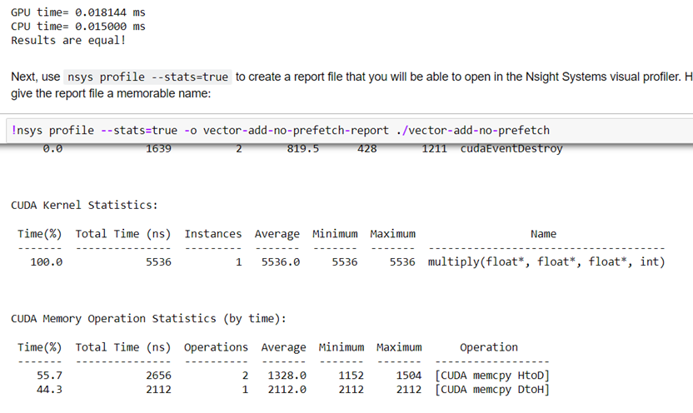

N= 256: 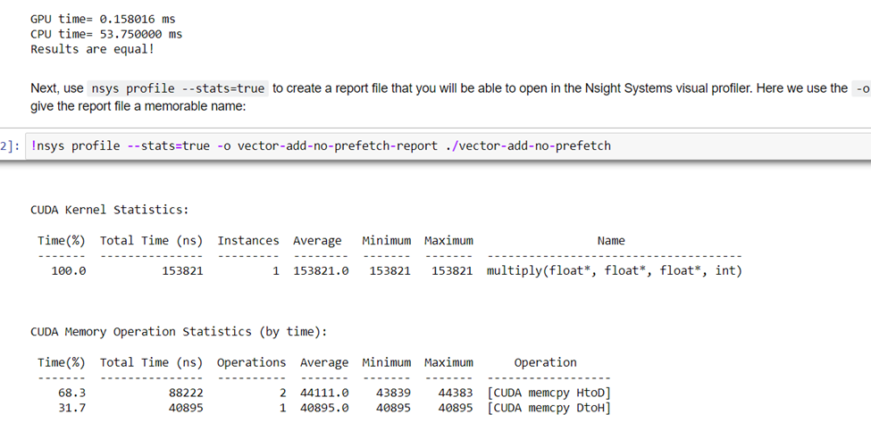

N=512 :

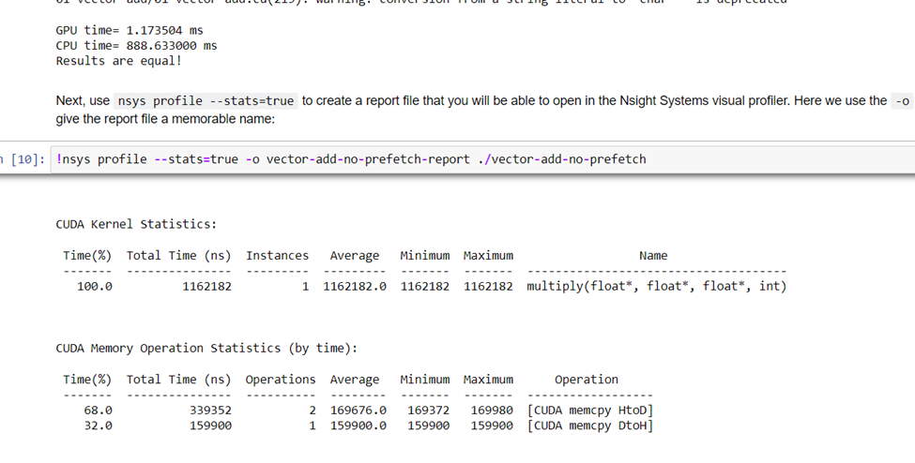

1024 :

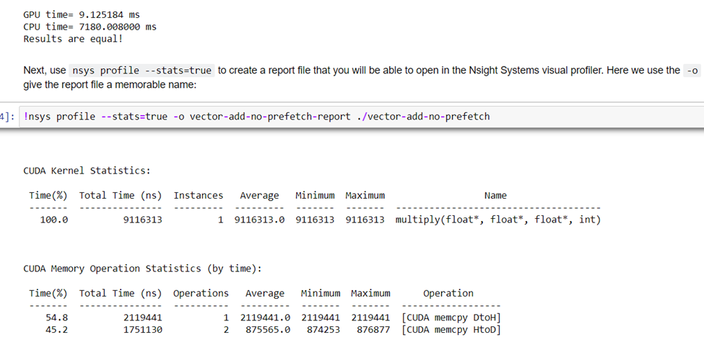

**Problem Statement 3:**

Implement Prefix sum using CUDA C. Analyze and tune the program for getting maximum speed up. Do Profiling and state what part of the code takes the huge amount of time to execute.

**Answer:**

*#include <bits/stdc++.h>*

*using std::accumulate;*

*using std::generate;*

*using std::cout;*

*using std::vector;*

*#define SHMEM_SIZE 1024*

*void init(vector<int>& h_v){*

*for(int i=0;i<h_v.size();++i){*

*h_v[i]=rand()%10;*

*}*

*}*

*__global__ void scan(int *g_odata, int *g_idata, int *tmp, int n )*

*{*

*extern __shared__ int temp[1024];*

*int thid = threadIdx.x;*

*int dataid = blockDim.x*blockIdx.x+threadIdx.x;*

*temp[thid] =g_idata[dataid];*

*__syncthreads();*

*for (int offset = 1; offset < n && offset<blockDim.x; offset *= 2)*

*{*

*if (thid >= offset)*

*temp[thid] = temp[thid - offset]+ temp[thid];*

*__syncthreads();*

*}*

*g_odata[dataid] = temp[thid];*

*if(thid==blockDim.x-1){tmp[blockIdx.x]=temp[thid];}*

*}*

*/*__global__ void block_scan(int *g_odata,int *tmp, int n)*

*{*

*int dataid = blockDim.x*blockIdx.x+threadIdx.x;*

*if(dataid>=n) return;*

*tmp[dataid] =g_odata[dataid];*

*__syncthreads();*

*for (int offset = 1; offset < gridDim.x ; offset *= 2)*

*{*

*if (dataid >= offset*blockDim.x)*

*{*

*if((blockDim.x*blockIdx.x-((offset-1)*blockDim.x)-1)>=0){*

*//all in all elements*

*tmp[dataid] += tmp[blockDim.x*blockIdx.x-((offset-1)*blockDim.x)-1];*

*}*

*}*

*__syncthreads();*

*}*

*g_odata[dataid] = tmp[dataid];*

*}*/*

*__global__ void block_sum(int *d_v_r,int *tmp, int n)*

*{*

*int dataid = blockDim.x*blockIdx.x+threadIdx.x;*

*if(blockIdx.x>0 && dataid<n)*

*d_v_r[dataid]+=tmp[blockIdx.x-1];*

*}*

*int main() {*

*// Vector size*

*int N = 1 << 12;*

*//N = 50;*

*size_t bytes = N * sizeof(int);*

*// Host data*

*vector<int> h_v(N);*

*vector<int> h_v_r(N);*

*// Initialize the input data*

*init(h_v);*

*/*for(int i=0;i<N;++i){*

*cout<<h_v[i]<<" ";*

*}*

*cout<<"\n";*/*

*// Allocate device memory*

*int *d_v, *d_v_r,*tmp,*tmp2;*

*cudaMallocManaged(&d_v, bytes);*

*cudaMallocManaged(&d_v_r, bytes);*

*// Copy to device*

*cudaMemcpy(d_v, h_v.data(), bytes, cudaMemcpyHostToDevice);*

*/*for(int i=0;i<N;++i){*

*cout<<d_v[i]<<" ";*

*}*/*

*// TB Size*

*cout<<"\n";*

*const int TB_SIZE = 32;*

*// Grid Size (No padding)*

*int GRID_SIZE = (N+TB_SIZE-1)/TB_SIZE;*

*cudaMallocManaged(&tmp, GRID_SIZE*sizeof(int));*

*cudaMallocManaged(&tmp2, GRID_SIZE*sizeof(int));*

*// Call kernels*

*scan<<<GRID_SIZE,TB_SIZE>>>(d_v_r,d_v,tmp,N);*

*scan<<<1,GRID_SIZE>>>(tmp2,tmp,tmp,GRID_SIZE);*

*//block_scan<<<GRID_SIZE,TB_SIZE>>>(d_v_r,tmp,N);*

*block_sum<<<GRID_SIZE,TB_SIZE>>>(d_v_r,tmp2,N);*

*// Copy to host;*

*cudaMemcpy(h_v_r.data(), d_v_r, bytes, cudaMemcpyDeviceToHost);*

*/* for(int i=0;i<N;++i){*

*cout<<h_v_r[i]<<" ";*

*}*/*

*int t=0;*

*for(int i=0;i<N;i++){*

*t+=h_v[i];*

*if(t!=h_v_r[i]){*

*cout<<"Failed";*

*cout<<i;*

*break;*

*}*

*}*

*cout << "COMPLETED SUCCESSFULLY\n";*

*return 0;*

*}*

**N=1<<12 and TB=32**

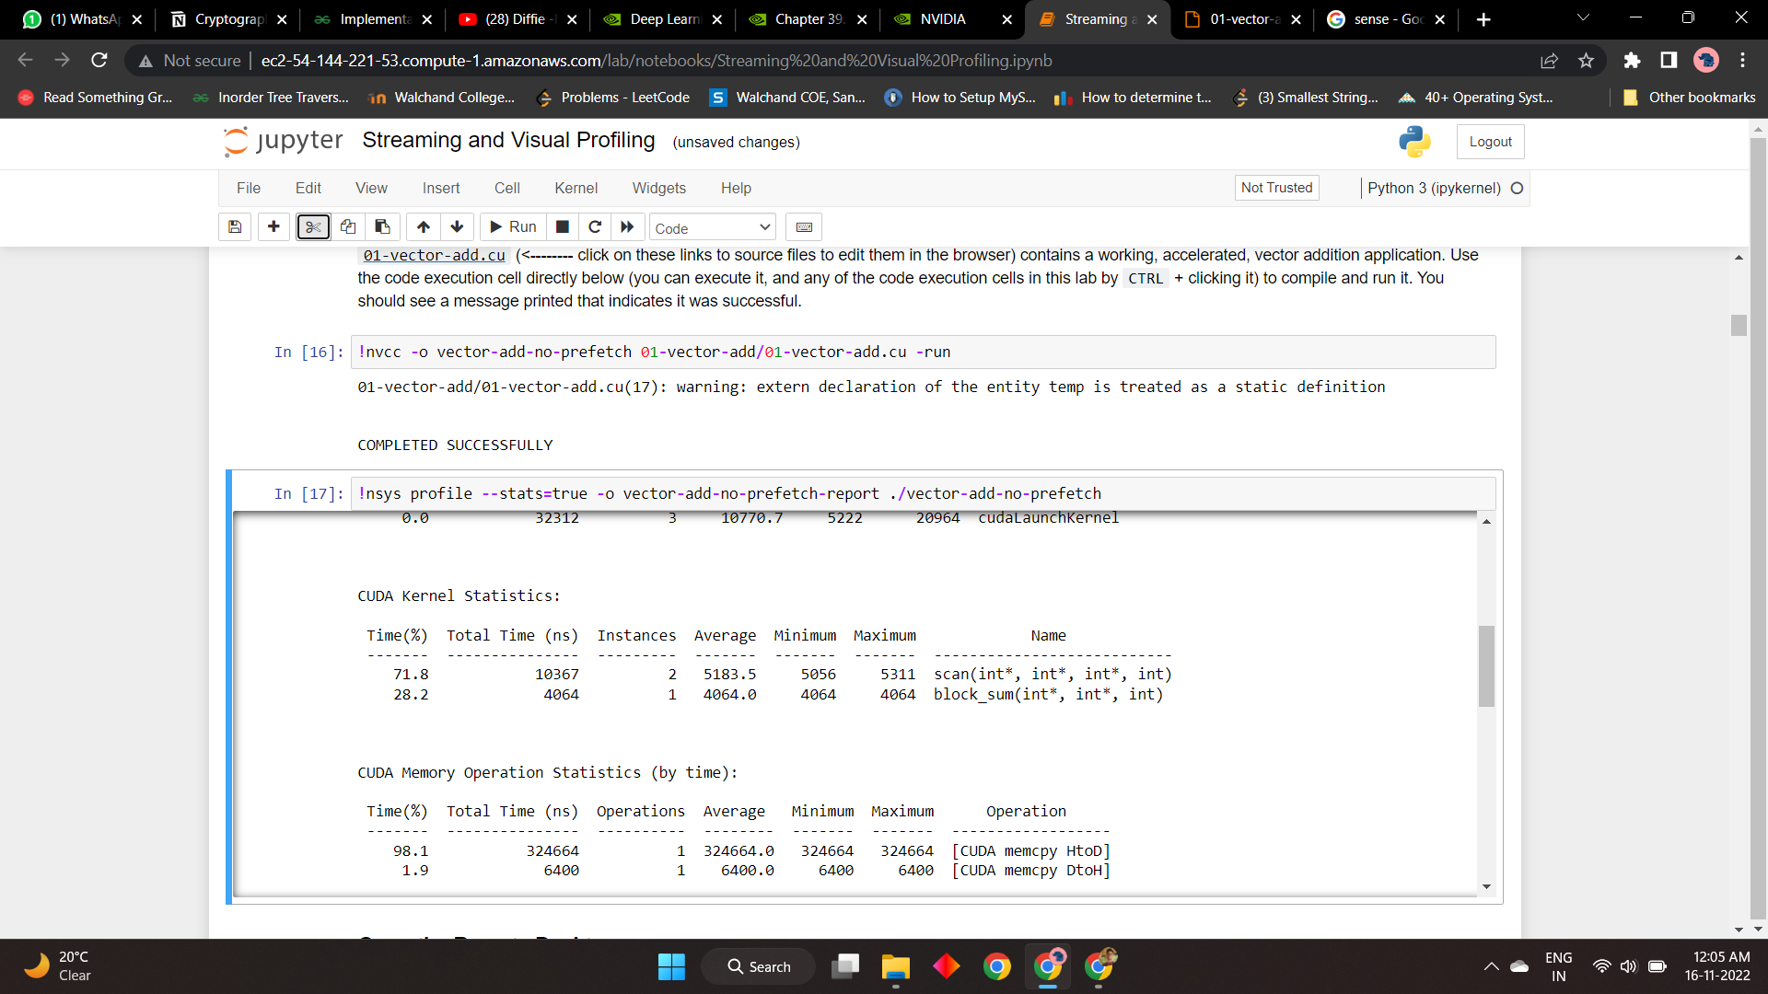

**N=1<<12 and TB=128**

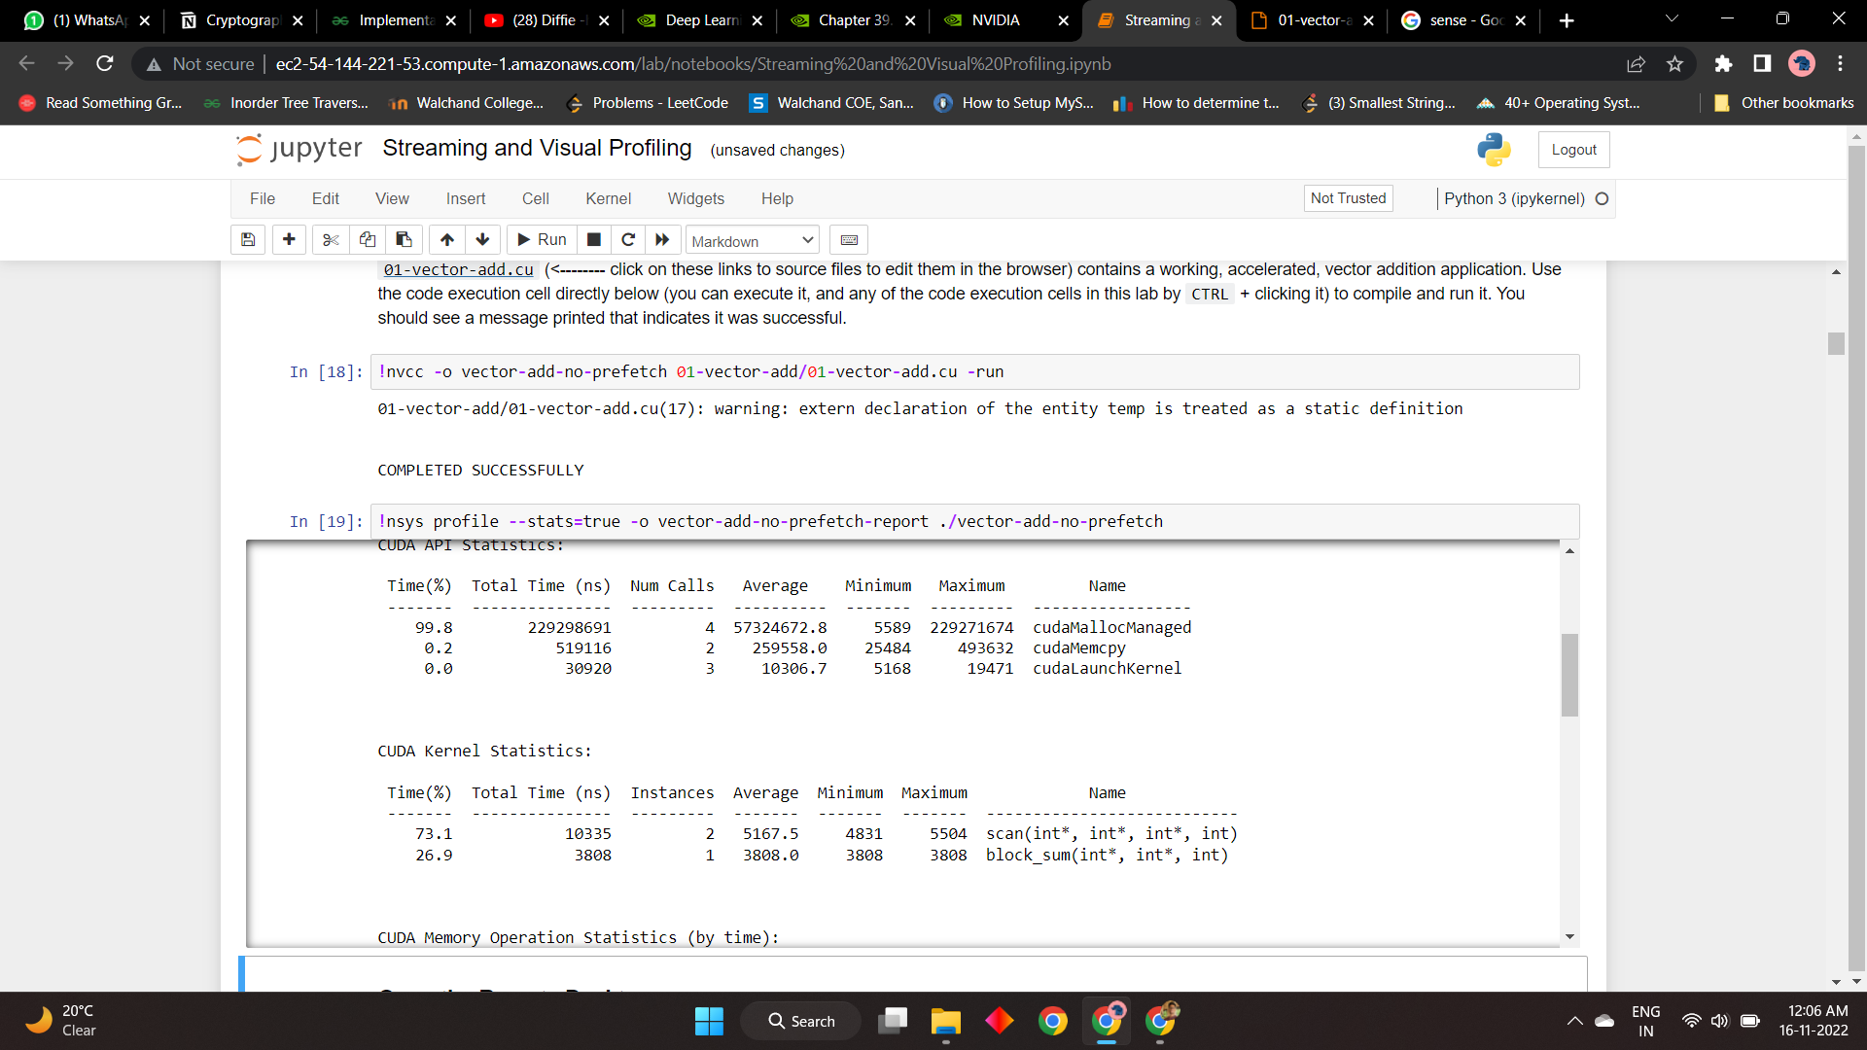

**N=1<<12 and TB=256**

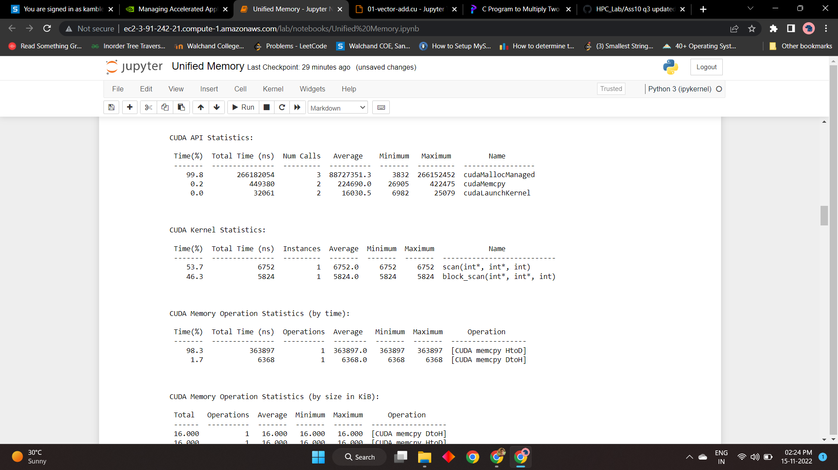

**N=1<<12 and TB=512**

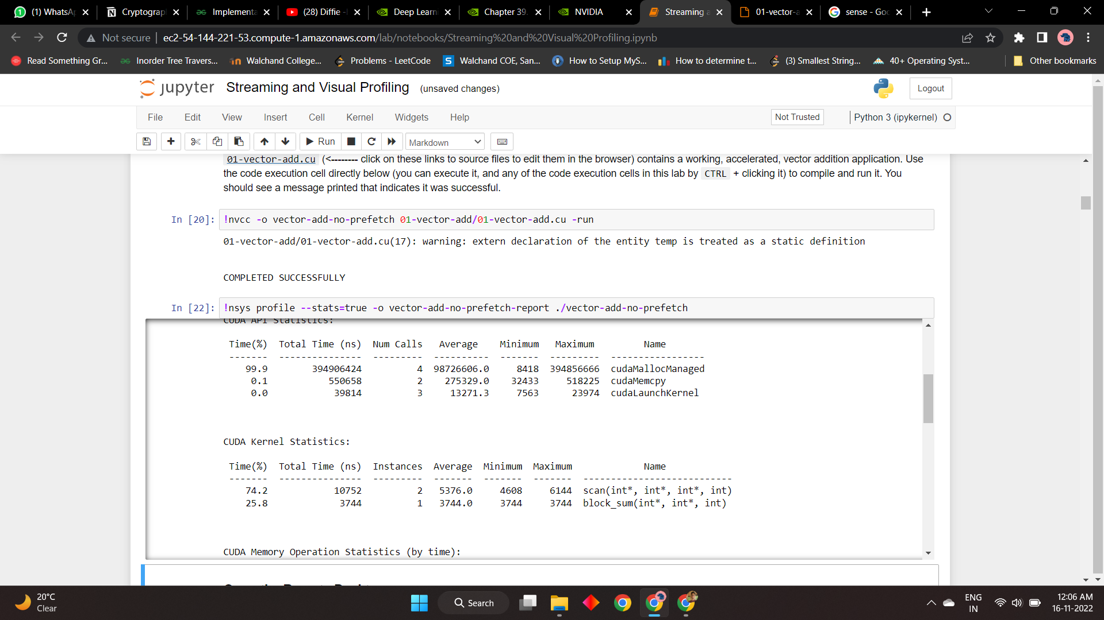

| N and number of thread per block | time(ns) |
| --- | --- |
| N=1<<12 and TB=32 | 14431 |
| N=1<<12 and TB=128 | 14,141 |
| N=1<<12 and TB=256 | 12,576 |
| N=1<<12 and TB=512 | 14,496 |

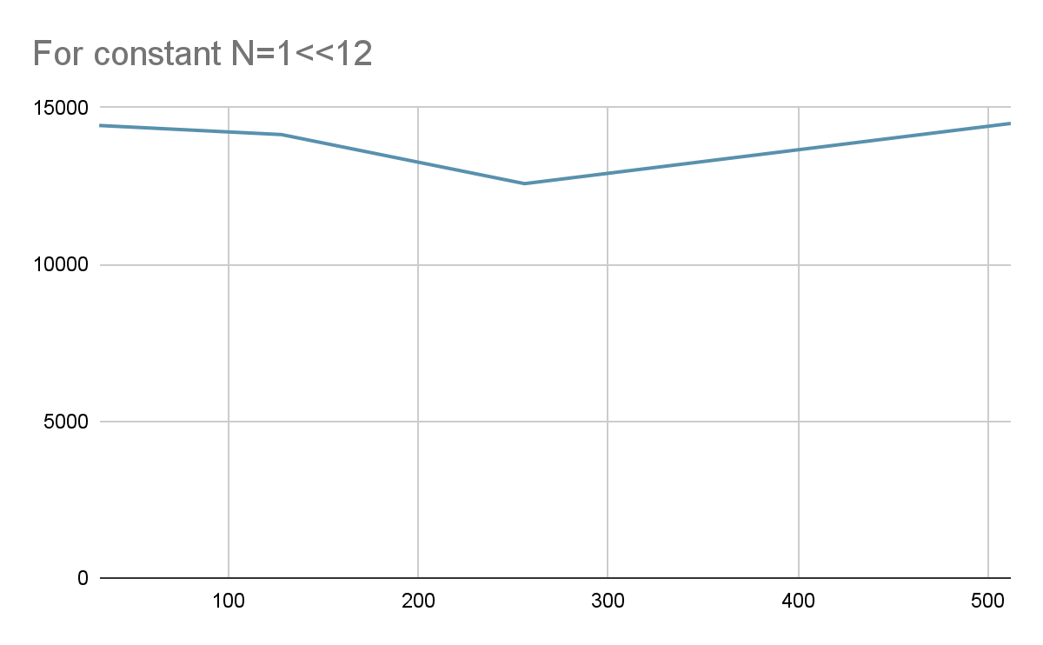

**Problem Statement 4:**

Implement 2D Convolution using shared memory using CUDA C. Analyze and tune the program for getting maximum speed up. Do Profiling and state what part of the code takes the huge amount of time to execute.

// This program implements 2D convolution in CUDA

#include<bits/stdc++.h>

// 7 x 7 convolutional mask

#defineMASK_DIM7

// Amount the the matrix will hang over the matrix

#defineMASK_OFFSET (MASK_DIM / 2)

// Allocate mask in constant memory

__constant__intmask[7*7];

// 2D Convolution Kernel

// Takes:

// matrix: Input matrix

// result: Convolution result

// N: Dimensions of the matrices

__global__voidconvolution_2d(int*matrix, int*result, intN) {

// Calculate the global thread positions

int row =blockIdx.y*blockDim.y+threadIdx.y;

int col =blockIdx.x*blockDim.x+threadIdx.x;

// Starting index for calculation

intstart_r= row - MASK_OFFSET;

intstart_c= col - MASK_OFFSET;

// Temp value for accumulating the result

int temp =0;

// Iterate over all the rows

for (inti=0; i< MASK_DIM; i++) {

// Go over each column

for (int j =0; j < MASK_DIM; j++) {

// Range check for rows

if ((start_r+i) >=0&& (start_r+i) < N) {

// Range check for columns

if ((start_c+ j) >=0&& (start_c+ j) < N) {

// Accumulate result

temp+=matrix[(start_r+i) * N + (start_c+ j)] *

mask[i* MASK_DIM + j];

}

}

}

}

// Write back the result

result[row * N + col] = temp;

}

// Initializes an n x n matrix with random numbers

// Takes:

// m : Pointer to the matrix

// n : Dimension of the matrix (square)

voidinit_matrix(int*m, intn) {

for (inti=0; i< n; i++) {

for (int j =0; j < n; j++) {

m[n *i+ j] =rand() %100;

}

}

}

// Verifies the 2D convolution result on the CPU

// Takes:

// m: Original matrix

// mask: Convolutional mask

// result: Result from the GPU

// N: Dimensions of the matrix

voidverify_result(int*m, int*mask, int*result, intN) {

// Temp value for accumulating results

int temp;

// Intermediate value for more readable code

intoffset_r;

intoffset_c;

// Go over each row

for (inti=0; i< N; i++) {

// Go over each column

for (int j =0; j < N; j++) {

// Reset the temp variable

temp=0;

// Go over each mask row

for (int k =0; k < MASK_DIM; k++) {

// Update offset value for row

offset_r=i- MASK_OFFSET + k;

// Go over each mask column

for (int l =0; l < MASK_DIM; l++) {

// Update offset value for column

offset_c= j - MASK_OFFSET + l;

// Range checks if we are hanging off the matrix

if (offset_r>=0&&offset_r< N) {

if (offset_c>=0&&offset_c< N) {

// Accumulate partial results

temp+=m[offset_r* N +offset_c] *mask[k * MASK_DIM + l];

}

}

}

}

// Fail if the results don't match

assert(result[i* N + j] == temp);

}

}

}

intmain() {

// Dimensions of the matrix (2 ^ 10 x 2 ^ 10)

int N =1<<10;

// Size of the matrix (in bytes)

size_tbytes_n= N * N *sizeof(int);

// Allocate the matrix and initialize it

int*matrix =newint[N * N];

int*result =newint[N * N];

init_matrix(matrix, N);

// Size of the mask in bytes

size_tbytes_m= MASK_DIM * MASK_DIM *sizeof(int);

// Allocate the mask and initialize it

int*h_mask=newint[MASK_DIM * MASK_DIM];

init_matrix(h_mask, MASK_DIM);

// Allocate device memory

int*d_matrix;

int*d_result;

cudaMalloc(&d_matrix, bytes_n);

cudaMalloc(&d_result, bytes_n);

// Copy data to the device

cudaMemcpy(d_matrix, matrix, bytes_n, cudaMemcpyHostToDevice);

cudaMemcpyToSymbol(mask, h_mask, bytes_m);

// Calculate grid dimensions

int THREADS =16;

int BLOCKS = (N + THREADS -1) / THREADS;

// Dimension launch arguments

dim3block_dim(THREADS, THREADS);

dim3grid_dim(BLOCKS, BLOCKS);

// Perform 2D Convolution

convolution_2d<<<grid_dim, block_dim>>>(d_matrix, d_result, N);

// Copy the result back to the CPU

cudaMemcpy(result, d_result, bytes_n, cudaMemcpyDeviceToHost);

// Functional test

verify_result(matrix, h_mask, result, N);

std::cout<<"COMPLETED SUCCESSFULLY!";

// Free the memory we allocated

delete[] matrix;

delete[] result;

delete[]h_mask;

cudaFree(d_matrix);

cudaFree(d_result);

return0;

}

| Problem size | 2^4* 2^4 | 2^5 * 2^5 | 2 ^ 10 * 2^10 |
| --- | --- | --- | --- |
| No.of Threads | time | time | time |
| 1 | 11296 | 18143 | 10303673 |
| 4 | 12064 | 12383 | 1187117 |
| 8 | 12256 | 12256 | 593431 |
| 16 | 9503 | 11776 | 313499 |
| 32 |  | 11488 | 270364 |

**Answer:**

Keeping thread constant graph against time and N

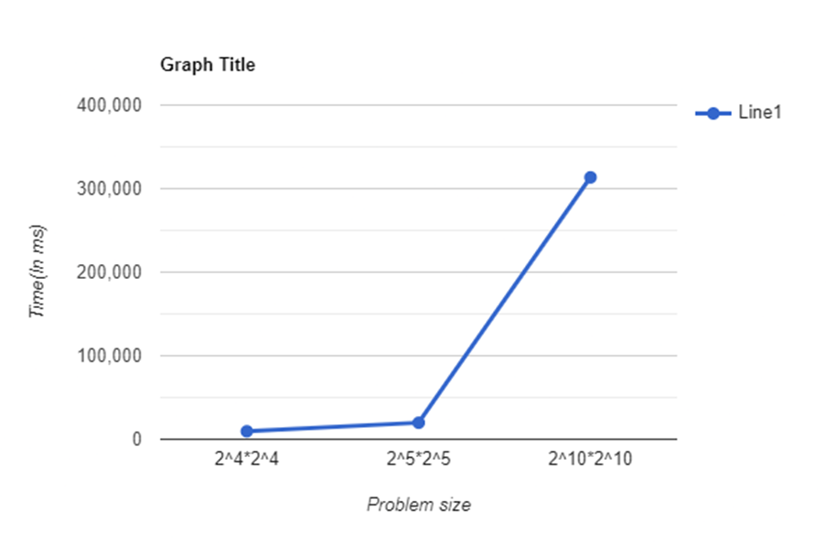

**Keeping problem size constant : 2^10 * 2^10 matrix**

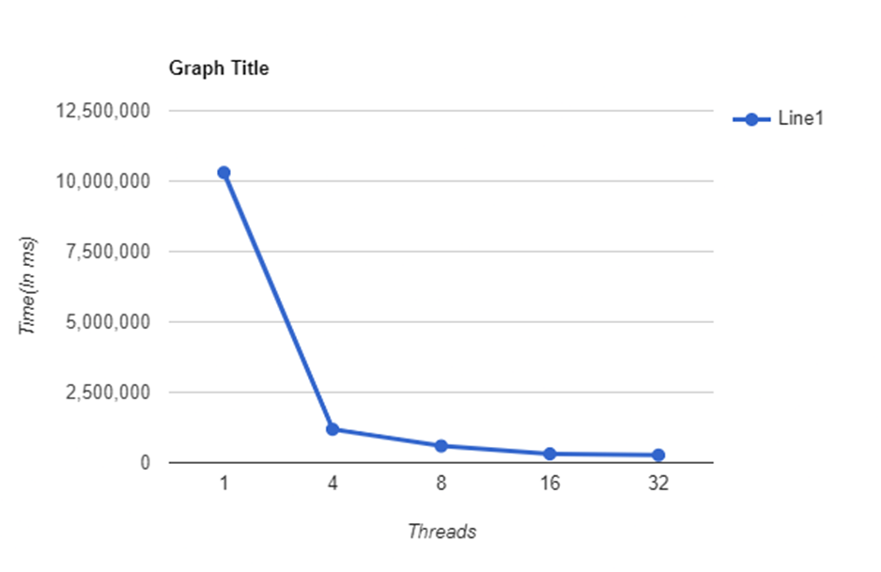

**2^5 * 2^5 matrix**

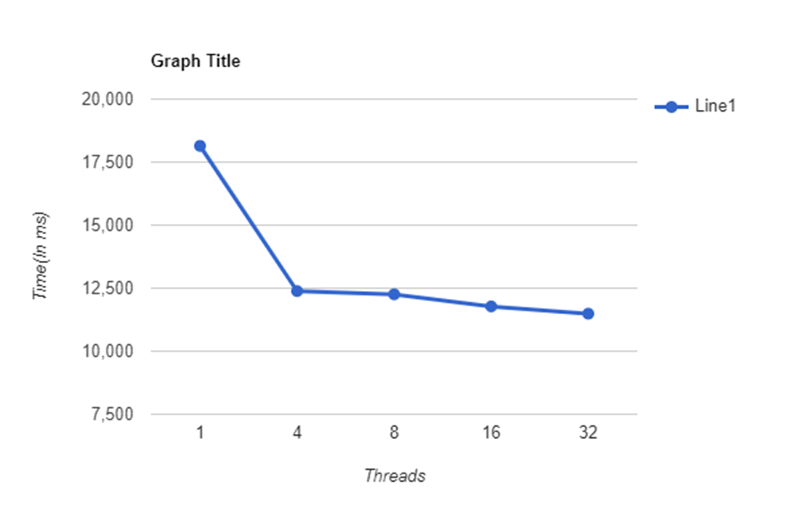

**2^4 * 2^4 matrix**

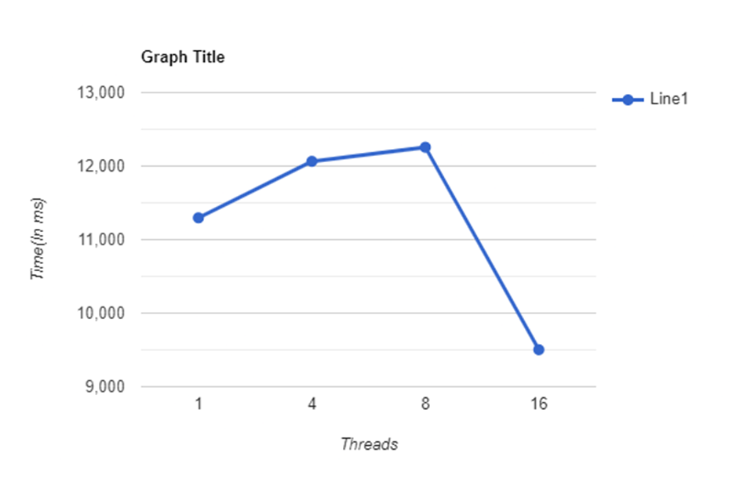

**Github Link:** [**https://github.com/OnkarGavali/HPC_Lab/tree/main/Practical_No10**](https://github.com/OnkarGavali/HPC_Lab/tree/main/Practical_No10)